7COM1079-0901-2025 - Team Research and Development Project

Final report title: Analysis of Maximum Heart Rate Differences in Patients With and Without Heart Disease

Group ID: A3

Dataset number: DS234

Prepared by: Saumya Jayaraman (23072454)
Temitoyosi Folafoluwa Osibemekun (24100632)
Fairooz Rashed (24165566)
Shahzad Ahmad (23008330)
Zoraize Saeed (24172729)

University of Hertfordshire
Hatfield, 2025

Table of Contents

- Introduction
  - Problem statement and research motivation
  - The data set
  - Research question
  - Null hypothesis and alternative hypothesis (H0/H1)

- Background research
  - Research papers
  - Why RQ is of interest

- Visualisation
  - Appropriate plot for the RQ output of an R script and supplementary graph/table
  - Additional information relating to understanding the data
  - Useful information for the data understanding

- Analysis
  - Statistical test used to test the hypotheses and output
  - The null hypothesis is rejected based on the p-value

- Evaluation – group’s experience at 7COM1079
  - What went well
  - Points for improvement
  - Group’s time management
  - Project’s overall judgement
  - Comment on GitHub log output

- Conclusions
  - Results explained.
  - Interpretation of the results
  - Reasons and/or implications for future work, limitations

- Reference list
- Appendices
- R code used for analysis and visualisation.
- GitHub log output.

1. Introduction

  - Problem statement and research motivation (100 words)

Cardiovascular diseases are the leading cause of global mortality, resulting in nearly 18 million deaths annually (WHO, 2023). Consequently, early risk assessment is essential.

Maximum Heart Rate (MaxHR) during exercise reflects the heart’s capacity to cope with physical stress, a performance metric suggested to differ significantly between individuals with and without heart disease (Brubaker and Kitzman, 2011). If this difference is meaningful, MaxHR could serve as a practical screening indicator. This study employs statistical hypothesis testing on clinical data to investigate whether mean MaxHR differs significantly between patients with and without heart disease, thereby supporting improved early detection and preventive care strategies.

  - The data set (75 words)

This study analyzed clinical data from 270 patients in the UCI Heart Disease dataset (Dua and Graff, 2019). We focused on two variables: Maximum Heart Rate (MaxHR) during exercise and the patient's heart disease status (present or absent). This structured dataset facilitated the comparison of cardiovascular performance to gain insight into how MaxHR differs between individuals with and without a heart disease diagnosis.

  - Research question (50 words).

Is there a difference in the mean maximum heart rate (MaxHR) between patients with diagnosed heart disease and patients without heart disease?

This question examines whether cardiovascular performance, measured through exercise capacity, differs significantly between these two clinical groups.

  - Null hypothesis and alternative hypothesis (H0/H1) (100 words)

Null Hypothesis (H₀): There is no difference in the mean maximum heart rate between patients with diagnosed heart disease and patients without heart disease.

Alternative Hypothesis (H₁): There is a difference in the mean maximum heart rate between patients with diagnosed heart disease and patients without heart disease.

These hypotheses will be tested using an independent samples t-test with a significance level of 0.05. If the p-value is less than 0.05, the null hypothesis will be rejected, indicating a statistically significant difference in mean MaxHR between the two groups.

- Background research

  - Research papers (at least 3 relevant to your topic / DS) (200 words)

Maximum heart rate (MaxHR) is a clinically important indicator of cardiovascular function, particularly during exercise, where it reflects chronotropic competence, the heart’s ability to increase rate in response to physical stress. Brubaker and Kitzman (2011) highlight that individuals with impaired chronotropic response, a condition commonly associated with coronary artery disease, often fail to reach normal expected MaxHR levels during exertion. This impairment is linked to poorer cardiac performance and has been shown to predict adverse clinical outcomes. Research using the UCI Heart Disease dataset has also identified MaxHR as a consistently influential variable in predictive models. Amin, Chiam and Varathan (2019) demonstrated that MaxHR was among the strongest predictors of heart disease when evaluating several machine-learning models applied to this dataset. Their findings suggest that MaxHR carries meaningful discriminative power beyond other physiological markers. The dataset used in the present study originates from the University of California Irvine Machine Learning Repository (Dua & Graff, 2019), one of the most widely utilised benchmark datasets for heart disease prediction. Studies using this dataset frequently prioritise classification accuracy, yet descriptive and inferential comparisons of individual physiological variables such as MaxHR are notably less common in the literature.

  - Why RQ is of interest (research gap and future directions according to the literature) (100 words)

Although MaxHR is recognised clinically as an important indicator of cardiac function, research using the UCI Heart Disease dataset has predominantly focused on building predictive models rather than statistically examining whether mean MaxHR differs between patients with and without heart disease. This represents a clear gap, as understanding group-level physiological differences can complement predictive approaches and strengthen interpretation of model features. Investigating whether mean MaxHR varies significantly between diagnostic groups provides a direct inferential test of patterns suggested by clinical theory and machine-learning feature importance. Future work could explore multivariable models that integrate MaxHR with other exercise-related measures to better characterise cardiovascular impairment.

- Visualisation

  - Appropriate graphs for the RQ (50 words)

A histogram of Maximum Heart Rate (MaxHR) was created to assess its distribution and confirm suitability for parametric testing. A bar plot comparing mean MaxHR across heart-disease groups was also produced to visualise group differences. Together, these plots directly support the research question by illustrating variation in MaxHR within and between groups.

  - Additional information relating to understanding the data (50 words)

The histogram shows that MaxHR follows an approximately normal distribution, supporting the use of a t-test.

The bar plot highlights a clear difference in average MaxHR between the two groups, with noticeably lower values in patients with heart disease. Error bars provide useful context by illustrating variability within each group.

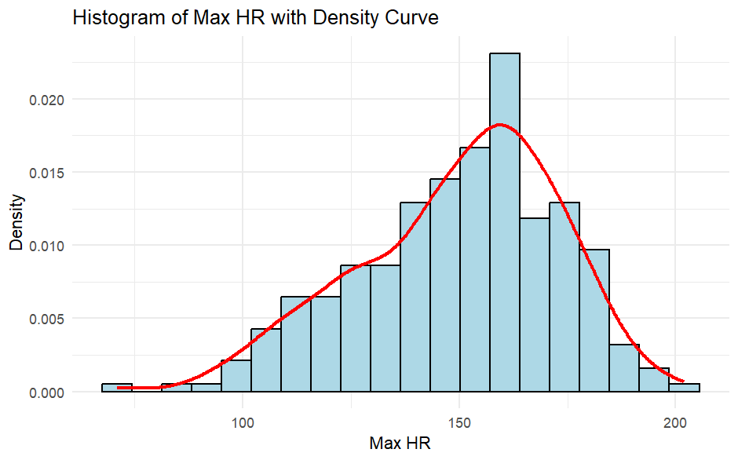Figure 1. Histogram of Maximum Heart Rate (MaxHR) with Density Curve

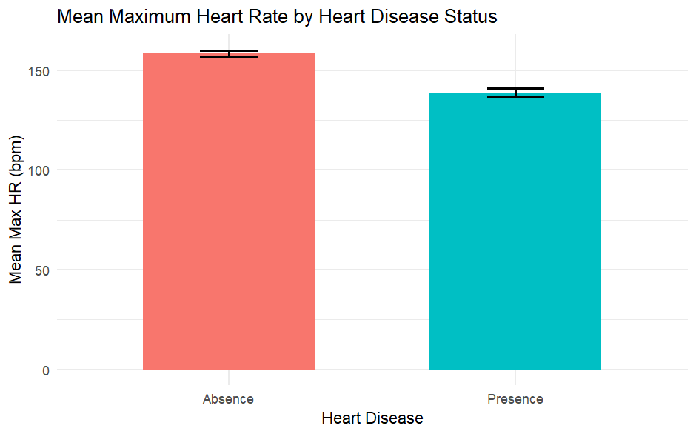
Figure 2. Barplot of Mean Maximum Heart Rate by Heart Disease Status

  - Useful information for the data understanding (50 words)

Visual patterns indicate that individuals without heart disease consistently achieve higher MaxHR values than those with diagnosed heart disease. This aligns with the statistical results and suggests reduced cardiovascular response in the affected group. The combination of distributional and comparative plots strengthens confidence in the observed relationship between MaxHR and heart-disease status.

- Analysis

  - Statistical test used to test the hypotheses and output (75 words)

The study compared the mean Maximum Heart Rate (MaxHR) between patients with (n = 120) and without heart disease (n = 150). Because MaxHR is continuous and the groups are independent, Welch’s independent samples t-test was selected. A histogram confirmed that MaxHR was approximately normally distributed, supporting the use of a parametric test. Welch’s method was used because it does not assume equal variances between groups, making it a robust choice for this dataset.

  - The null hypothesis is rejected based on the p-value (100 words)

Welch’s t-test showed a statistically significant difference in Maximum Heart Rate (MaxHR) between patients with and without heart disease (t = 7.39, df = 231.07, p = 2.60 × 10⁻¹²). Because the p-value is far below the 0.05 threshold, the null hypothesis is rejected. The 95% confidence interval for the mean difference (14.29 to 24.66) does not include zero, confirming a meaningful effect. Patients without heart disease had a higher mean MaxHR (158.33 bpm) compared to those with heart disease (138.86 bpm). This represents a mean difference of approximately 19.5 bpm between groups, suggesting that reduced MaxHR is associated with heart disease in this dataset.

- Evaluation – group’s experience at 7COM1079

  - What went well (75 words)

Our group established an excellent foundation early on through effective collaboration. We met regularly and maintained clear communication about individual roles, allowing us to quickly select our dataset and allocate tasks efficiently. The team's constructive contributions during initial discussions ensured a shared understanding, enabling us to meet early milestones smoothly and align the project perfectly with module expectations.

  - Points for improvement (75 words)

A decline in group coordination and engagement emerged following the initial planning stages. Communication gaps developed, which hindered momentum and resulted in delayed task completion. Critical responsibilities were left unfinished until late in the process, increasing pressure on active members. For future projects, clearer, sustained accountability and consistent communication are essential to improve workflow, maintain momentum, and prevent the necessity of last-minute corrective work.

  - Group’s time management (50 words)
The time management of the group was not as effective as it should have been. While deadlines were discussed and meetings were set, much of the substantive work was done later within the project timeline. This made iteration, peer review, and refinement difficult to achieve. Although efforts were made to try to keep the group on schedule, earlier and more consistent engagement by all members would have alleviated some time pressure and improved overall efficiency.

  - Project’s overall judgement (50 words)

Despite the challenges that arose, the core objectives of the project were met. The research question was well-framed, relevant statistical methods were used, and results made sense in the light of statistical thinking and existing literature. The final output shows a good comprehension of the principles of Inferential Statistics, Data Visualisation, and Reproducible Analysis in R. The quality of the project could be improved if the group coordination and time factor had been managed in a better way.

  - Comment on the GitHub log output (50 words)
- Commit Message: [Ran a few histograms to study how each column is distributed, also contains code for populating the first five rows and the total number of rows.] This was used to come up with the research question and prepare for the demo.
- Commit Message: [Added the entire block of code for the report. Contains the following: > Group means > Histogram > Barplot > t-test] This was the entire code block used for this report.
- Commit Message: [added histogram of maximum heart rate with an overlaid kernel density curve] This change added a distributional check for MaxHR, supporting the use of parametric inference and improving the clarity and robustness of the analysis.

- Conclusions
  - Results explained (75 words)

The current study sought to establish whether maximum heart rate varies in patients with and without heart disease. The results showed that patients with a diagnosis of heart disease tend to achieve lower maximum heart rates compared to patients without a diagnosis. This was consistent through the sample and large in extent, as would be expected to indicate a meaningful difference between the two groups, rather than a minor or random variation.

  - Interpretation of the results (75 words)

The observed pattern supports established physiological understanding of cardiovascular disease, with impaired cardiac function and diminished ability of the heart to respond to physical stress commonly associated with reduced maximum heart rate. In such contexts, lower MaxHR among heart patients may reflect limitations in cardiac output or chronotropic response. The findings indicate that MaxHR captures an aspect of cardiovascular performance that differentiates between healthier patients and those with underlying conditions of the heart, thereby reinforcing its relevance as an informative clinical and analytical variable.

  - Reasons and/or implications for future work, limitations of your study (50 words)

Despite obvious group differences being present, this paper has its limitations. The current analysis is single and cross-sectional; thus, no causality can be drawn from it. No consideration was given to important factors such as medication use, physical fitness, or disease severity that may influence maximum heart rate. Subsequent studies might follow upon this work by adding multivariable models that control for confounders, or using longitudinal data to examine how changes in MaxHR over time relate to disease progression and outcomes.

- Reference list

World Health Organization (2023) Cardiovascular diseases (CVDs). Available at: https://www.who.int/news-room/fact-sheets/detail/cardiovascular-diseases-(cvds) (Accessed: 05 December 2025).

Shinde, S.G. (2025) ‘AI-driven early detection of heart disease through machine learning and clinical metrics’, International Journal of Future Multidisciplinary Research (IJFMR). Available at: https://www.ijfmr.com/papers/2025/5/55976.pdf (Accessed: 06 December 2025).

Brubaker, P.H. and Kitzman, D.W. (2011) ‘Chronotropic incompetence: causes, consequences, and management’, Circulation, 123(9), pp. 1010–1020. doi: 10.1161/CIRCULATIONAHA.110.940577.

Amin, M.S., Chiam, Y.K. and Varathan, K.D. (2019) ‘A study on heart disease prediction using machine learning’, 2019 IEEE Conference on Big Data and Analytics, pp. 1–6.

Dua, D. and Graff, C. (2019) UCI Machine Learning Repository: Heart Disease Data Set. Irvine, CA: University of California School of Information and Computer Science. Available at: https://archive.ics.uci.edu/ml/datasets/Heart+Disease (Accessed: 05 December 2025).

- Appendices
- R code used for analysis and visualisation

# Load required package
library(tidyverse)

# Read dataset
df <- read_csv("Heart_Disease_Prediction.csv")

# Convert Heart Disease variable to factor
df$Heart.Disease <- as.factor(df$Heart.Disease)

# -------------------------------------------------------
# 1. HISTOGRAM OF MAX HR
# -------------------------------------------------------

ggplot(df, aes(x = Max.HR)) +
geom_histogram(
aes(y = ..density..),
bins = 20,
fill = "lightblue",
colour = "black"
) +
geom_density(colour = "red", linewidth = 1) +
labs(
title = "Histogram of Max HR with Density Curve",
x = "Max HR",
y = "Density"
) +
theme_minimal()

# -------------------------------------------------------
# 2. GROUP MEANS & STANDARD ERROR (for barplot)
# -------------------------------------------------------

group_means <- df %>%
group_by(Heart.Disease) %>%
summarise(
mean_maxhr = mean(Max.HR, na.rm = TRUE),
se_maxhr = sd(Max.HR, na.rm = TRUE) / sqrt(n())
)

# -------------------------------------------------------
# 3. BARPLOT OF MEAN MAX HR BY HEART DISEASE STATUS
# -------------------------------------------------------

ggplot(group_means, aes(x = Heart.Disease, y = mean_maxhr, fill = Heart.Disease)) +
geom_col(width = 0.6) +
geom_errorbar(
aes(ymin = mean_maxhr - se_maxhr, ymax = mean_maxhr + se_maxhr),
width = 0.2,
size = 0.8
) +
labs(
title = "Mean Maximum Heart Rate by Heart Disease Status",
x = "Heart Disease",
y = "Mean Max HR (bpm)"
) +
theme_minimal() +
theme(legend.position = "none")

# -------------------------------------------------------
# 4. INDEPENDENT SAMPLES T-TEST
# -------------------------------------------------------

t.test(Max.HR ~ Heart.Disease, data = df)

- GitHub log output.




c0a231b Saumya Jayaraman 2025-12-12 Contributors.csv final update
809cd67 Saumya-Jay 2025-12-12 Merge pull request #8 from DevShahzadAhmad/Saumya
fc2c787 Saumya Jayaraman 2025-12-12 Merge branch 'Saumya' of https://github.com/DevShahzadAhmad/Team_RnD_Project_Repo into Saumya
b2f50be Saumya Jayaraman 2025-12-12 Making some final changes, refactoring the code. Adding comments.
283e761 DevShahzadAhmad 2025-12-12 Merge pull request #7 from DevShahzadAhmad/Dev_Shahzad
73f329b DevShahzadAhmad 2025-12-12 Merge pull request #6 from DevShahzadAhmad/main
ab1307c Shahzad Ahmad 2025-12-12 EDA on the dataset for better insights for research
b1126ac Temitoyosi Osibemekun 2025-12-12 Merge pull request #4 from DevShahzadAhmad/feat/dataset_exploration
014c24f Temitoyosi Osibemekun 2025-12-12 Merge pull request #5 from DevShahzadAhmad/Saumya
8fadb3a Temitoyosi Osibemekun 2025-12-12 Merge branch 'feat/dataset_exploration' into Saumya
f459172 Temitoyosi Osibemekun 2025-12-12 added histogram plot figure showing the distribution of Maximium heart rate
dfa3161 Temitoyosi Osibemekun 2025-12-12 added histogram of maximum heart rate with an overlaid kernel density curve
2f9dd2c Shahzad Ahmad 2025-12-12 Research on the presentation
a88c117 DevShahzadAhmad 2025-12-12 Merge pull request #3 from DevShahzadAhmad/main
30b08d0 Fairooz-Safa 2025-12-12 boxplot visualization for better analysis on introduction
436cf49 Fairooz-Safa 2025-12-11 My research on introduction and null hypothesis.
134f67a Saumya-Jay 2025-12-11 Merge pull request #2 from DevShahzadAhmad/Saumya
34118ae Saumya Jayaraman 2025-12-11 Merge branch 'Saumya' of https://github.com/DevShahzadAhmad/Team_RnD_Project_Repo into Saumya
729b7ff Saumya Jayaraman 2025-12-11 Reorganising files
e95aea8 Saumya Jayaraman 2025-12-11 Added the entire block of code for the report.Contains the following: > Group means > Histogram > Barplot > t-test
04ae107 Saumya Jayaraman 2025-12-11 1. Adding the entire code block for the project. Contains: > Group means > Histogram > Barplot > t-test 2. Contributors.csv
2c40580 Zoraize Saeed 2025-12-11 Added informative comments, data validation output
56dd6f6 Temitoyosi Osibemekun 2025-12-08 fix: convert Heart Disease to factor for clarity
c4b28a2 Temitoyosi Osibemekun 2025-12-08 feat: Compare summary statistics of MaxHR by heart disease group
d9c2070 to24abj 2025-12-08 Add group members github usernames in README.md
28d0fc3 to24abj 2025-12-07 feat: load and inspect dataset structure
f8ae7a6 to24abj 2025-12-03 Update README.md
8469a56 Temitoyosi Osibemekun 2025-12-03 refactor: deleted r file from project root
ace50e1 Temitoyosi Osibemekun 2025-12-03 merge branch main
0e450ae Temitoyosi Osibemekun 2025-12-03 refactor: repositiry structure
76f706e to24abj 2025-12-03 Update README.md
4e25647 to24abj 2025-12-03 Update README.md
609d5fe to24abj 2025-12-03 Create README.md
294efd9 Saumya Jayaraman 2025-12-03 Added more tests to support the RQ of choice.
1194b86 Saumya Jayaraman 2025-12-01 Ran a few histograms to study how each column is distributed, also contains code for populating the first five rows and the total number of rows.
8960e01 Saumya Jayaraman 2025-11-28 Adding a research file where the team can do all their research queries.
65608f7 Temitoyosi Osibemekun 2025-11-27 added gitignore and rproj files
d14c133 to24abj 2025-11-27 feat: uploaded dataset DS234

